 **Blood donation registration system**

Table of Contents

Acknowledgment 4

Abstraction: 5

Chapter 1 Introduction 5

1.1 Introduction to the project 5

1.2 System Background 5

1.3 Overview of the project 6

1.4 Justification: 6

1.5 Aims: 6

1.6 Objectives: 6

Chapter 2 Analysis 7

2.1 Introduction 7

2.2 Analysis Methodologies 7

2.3 Information Gathering 7

2.3 DEVELOPMENT METHODOLOGY 8

2.4 Feasibility Study 0

SRS (Software Requirement Specification): 0

Functional requirements: 0

Non-functional requirements: 1

2.5 MoSCoW Prioritization 2

2.6 Requirement Specification 3

2.7 Use Case Diagram 4

2.8 System Architecture 5

2.9 NLA 6

2.9.1 Initial Class diagram 7

Chapter 3: Design 8

3.1 Structural Modeling 9

3.2 Final Class Diagram 9

3.3 Data Flow Diagram (DFD) 11

3.4 Behavioral Modelling 13

3.4.1 Activity Diagram: 13

3.4.2 Sequence Diagram 17

Chapter 4: Implementation 19

4.1 UI-Modelling 20

4.1.1 Prototype: 20

Chapter 5 Testing 22

5.1 Blackbox Testing: 22

5.1.1 Benefits of black box testing: 22

6.User manual: 35

Chapter 7 40

7.1 Problem faced: 40

7.2 Limitations: 41

7.3 Risk management: 41

7.5 Configuration management 42

7.6 Future Work 43

Conclusion: 43

Appendix: 45

Codes: 45

Code for login page: 47

Codes of Index/ dashboard: 48

Codes for Adding donor: 55

Codes for View donor: 62

Codes for editing donor 69

Code for deleting donor: 76

Code for Creating campaigns: 82

Edit campaign: 84

View campaign: 85

Delete campaign: 86

# Acknowledgment

First, I would like our computer project tutor Mr. Sudeep Lal Bajimaya of the Softwarica College of IT & E-commerce for providing me and friends with proper instruction and guidance when necessary. Without his guidance this project might not have been completed.

Secondly, I would like to thank my Softwarica College of IT & E-commerce for providing the required resources to complete my project. I am thankful for all the lecture class about various programing languages, which made me capable of finishing this difficult project.

Also, to all the other tutor and companions who guided me with valuable guidelines I express my gratitude to them as well. They inspired me and motivative me to finish this project.

# 

# Abstraction:

Rare blood type is hard to find, in many cases, patient die because the proper blood type could not be found during emergency. My system aims to solve this issue by using the internet by enabling blood banks and hospital to locate proper blood type for patient faster and easier.

Blood Donor Online Registration System is a web base application where any individual or staff of any hospital or blood bank can keep an online record of donors with blood types and keep record of campaigns done by their organization with their location. The aim main of this system is create an online record of blood donors and make the record available online so that various blood banks/hospital can share each other’s record of donors and blood type, so that they can find proper blood donor for an immediate patient. The motto of this system is to help patients in need and save lives. This system is not developed for any business propose, it goal is to save people life by providing a platform for faster communication.

# Chapter 1 Introduction

## 1.1 Introduction to the project

We are living in the age of internet and technology. Using our technological advancement, a lot of good can be done in this world. My system is one those technological advancement intended to save life ad make people life easier. Blood Donor Online Registration System is a web base application where any individual or staff of any hospital or blood bank can keep a online record of donors with blood types and also keep record of campaigns done by their organization with their location. The main aim of this system is creating an online record of blood donors and make the record available online so that various blood banks/hospital can share each other’s record of donors and blood type, so that they can find proper blood for an immediate patient on time.

## 1.2 System Background

In the current time hospitals and blood banks in use old paper-based document system, where documents often get misplaced and damage. Also, the record kept are rarely shared with other organization. My system enables these organization to keep a digital record of the donor with their blood type and enable them to share this information with other organization for the immediate help of any patient.

## 1.3 Overview of the project

The Blood Donor Online Registration System going is developed with the login page where only individual of authentic organization can login for security purposes, they can add the record of the donor with their blood type and personal information plus, organization can keep record of various blood donation campaigns and share the information with each other.

Functionality of system:

* Secure database and login system.
* Friendly and easy user interface.
* Enable user to add, view, update and remove donors.
* Enable user to add, view, update and remove campaigns.
* Provide a digital platform to store these records, for better storage and accessibility.

## 1.4 Justification:

Many people die every day because suitable blood type cannot be found on time. The blood donor registration system helps to reduce the time of finding the suitable donors with a old paper base documentation system and helping organization share their information of various donor so that a suitable donor could be contacted to save a patient life. My system can be justified by the following reason,

* Making the record of the donor much easy to store and accessed compared to the paper base documentation system.
* Increase word speed, enabling more patient to be saved.
* Help find donors easily.
* Enables various organization to share information easily.
* Enables people to create digital record hence, the record are stored safly and has less probability for any damage.

## 1.5 Aims:

The main aim of this project is to develop a web-based application that can keep digital record of the donors or campaigns online and make the record accessible to various certified organization.

## 1.6 Objectives:

* To create a functional and secure web site
* To create a secure database and login system.
* To provide easy access of donor information.
* To provide means to add, view and delete donor information.
* Create fast and friend User interface.
* Perform proper testing and debug any issues.

# 

# Chapter 2 Analysis

## 2.1 Introduction

Analysis is the main phase in the lifecycle of software development, it assumes an important job when creating fresh frameworks and separate task into littler components in order to gain a superior understanding of the needs of the framework. At this point, all the prerequisites of the structure to be developed are differentiated and broken down

## 2.2 Analysis Methodologies

Analysis is the way to distinguish and characterize customers ' demands for an implementation that will be produced or altered. Analysis fuses most of the coordinating that facilitates to perceive the requirements of client. In this manner, the Analysis hopes to explore, approve and supervise the needs of the structure or programming.

Methodology of OOA includes sequence, class and activities diagram. Sequence diagram are the diagrams showing the relationship of information between classes validating and visualizing runtime scenarios. Class diagram explains the structure of the system by displaying system classes, attributes, or methods along with object relationships. Activity diagram explains the system's dynamic aspect which shows the system's flow events. These three diagrams are drawn for my project but in the design phase the illustration of the sequence diagram, class diagram and activity diagram is described.

## 2.3 Information Gathering

It's the gathering of functional, technical and system requirement from user, staff and employee. Before constructing a task, there should be a lot of exchanges that should be completed. Getting the correct requirement from the client can accomplish the projects in time. The reason for the information gathering structure is to assist arrange our association's efforts to turn out more inclusive, different methods are to be used to assemble information.

Interview: This approach is the most relevant information collection strategy where both parties will speak face to face about fulfilling the requirement. Using this approach, better info can be gathered that leads to a proper understanding of requirements and can also strengthen mutual understanding between both parties. Below is a list of the questions I asked during the interview

**Advantage:**

Interactive way for data collection.

Ideas and emotions are better understood, so there is less misunderstanding.

Enables in-depth collection of the information required.

**Disadvantage:**

Its time consuming and costly

There is probability of being bias, by both interviewer and the person giving the answer.

**SWOT**

SWOT is an important strategy for understanding characteristics and shortcomings of my project. It separates openings that are accessible to you and the risks that you face while constructing the project. I choose SWOT because it will collect the prerequisite as it is easy and useful techniques to examine the quality of the structure, its shortcomings, its openings and its hazards. In Swot we focus on the following areas:

**Strength:**

Benefit of your blood bank registration system?

What feature does your system offers compared other system in the m2.arket?

**Weakness:**

Things to avoid while developing the system?

What scion and environmental things that affects the system?

What improvement can be made in the system?

## 2.3 DEVELOPMENT METHODOLOGY

Methodology used

Since this project will have a single person in charge of evaluating, designing, developing, implementing and testing and no other teammates are to be involved, so waterfall methodology will be the best to use in this project. The project size is also tiny, so it is unlikely that project demands will alter. Methodology of waterfalls has some of these benefits over others such as agile. Some of the reason for choosing this methodology are as follow;

* Non-repetitive stages unlike agile.
* Easy and uncomplicated steps, beneficial for short project.
* Next stage only begins when the requirement of last stage is completed.
* Saves time and energy.
* Uncomplicates the project

This methodology isn’t without shortcomings some of them are as follow,

* Less room for errors.
* Going back to the previous stage is not possible
* If the requirement changes then you will have to run the stages all over again.
* No guarantee of user satisfaction as stockholders are not involved.



## 2.4 Feasibility Study

Feasibility study demonstrates if a task is conceivable to assemble or not. It examines the perceivability of a thought. This investigation decides whether the task is specialized, monetarily, socially, doable inside the assessed expense.

The various type of feasibility studies needed to be performed are as follow,

**Technical feasibility**: This evaluation center around the technical resource that are available, it chooses whether the specific portion of the association meets all the prerequisites. It also involves equipment evaluation, programming and other specific prerequisites.

**Economic feasibility:** Cost and benefit advantages inquires is tried in this feasibility. Money saving advantage inquiry gages and contrast benefits and similar expenditure plan designated for the task. The price of the assignment is explored, and it is decided whether it is compatible and conceivable to complete. It also acknowledges the economic benefits that a job will offer to the association.

**Legal feasibility:** It investigates whether the suggested framework conflicts with the legitimate necessities. Governmental problems may be the problem of the project being developed. It understands that the constitution of the country gives permission to create such a site or not.

**Operational feasibility:** It is used to differentiate the importance of certain issues and how to fathom them. It makes a step as it needs to follow that problem and undertaking an inquiry to break down and decide whether and how well the need of the association can be met by completing the assignment.

**Scheduling feasibility:** This feasibility is the most important for time accomplishment, all things considered, if not completed on timetable, a task will be bound to fail. In the event of booking, an organization assesses how much time the task will take to complete and chooses whether the undertaking will work as set out in the Gantt diagram.

## SRS (Software Requirement Specification):

The record that specifies the systems highlights such as functional and non-functional requirement is known as software requirement specification or SRS. A progressively formal procedure is required if separate gathering will develop the requirements.

### Functional requirements:

|  |  |  |  |  |
| --- | --- | --- | --- | --- |
| FRID | Functional requirement | Data | Rational | Dependencies |
| FR1 | Registration | Valid user information with valid organization info | To login into the system |  |
| FR2 | Login | Valid ID and password | To authenticate the admin | FR1 |
| FR3 | Add donor | Information about donor and their blood type | Adding donor information | FR 2 |
| FR4 | View all the information about the Donor including blood type | Information about donor and their blood type | Viewing donor information | FR 3 |
| FR5 | Delete or update donor | Information about donor | Deleting or updating the donor and its information. | FR 3 |
| FR6 | Add campaigns | Information about campaigns and their location. | Adding campaign information | FR 2 |
| FR7 | View all the information about the campaigns including their location. | Information about campaigns and their location. | Viewing campaign information | FR 6 |
| FR8 | Delete or update  Campaign | Information about campaigns and their location. | Deleting or updating the campaign info and its Location | FR 6 |
| FR9 | Log out | N/A | Logging out of the system | FR 2 |

### 

### Non-functional requirements:

|  |  |  |
| --- | --- | --- |
|  | Non-functional requirements | Rational |
| NFR1 | Privacy | Secure confidential information. |
| NFR2 | Effectiveness | Generating user-friendly, efficient website with better usability. |
| NFR3 | Dependability | Building a web-based application that customers can rely on. |
| NFR4 | Accessibility | Developing a website that can be accessed and used at any moment. |
| NFR 5 | Interoperable | making the website readily available on many platforms |
| NFR6 | Productivity | Creating website that is simple to navigate. |
| NFR 7 | Maintenance | Providing regular adequate maintenance. |

## 2.5 MoSCoW Prioritization

It is an agile methodology for understanding the priorities properly. It can be applied for tasks and requirements.

The word MOSCOW stands for;

M: Must have

S: Should have

C: Could have

W: wont' have

|  |  |  |
| --- | --- | --- |
| **ID** | **Functional and**  **Non-Functional Requirement** | **MoSCow** |
| FR1 | Registration | Must have |
| FR2 | Login | Must have |
| FR3 | Add donor | Must have |
| FR4 | View all the information about the Donor including blood type | Must have |
| FR5 | Delete or update donor | Should have |
| FR6 | Add campaigns | Must have |
| FR7 | View all the information about the campaigns including their location. | Must have |
| FR8 | Delete or update  Campaign | Should have |
| FR9 | Log out | Must have |
| NFR1 | Privacy | Must have |
| NFR2 | Effectiveness | Should have |
| NFR3 | Dependability | Must have |
| NFR4 | Accessibility | Should have |
| NFR 5 | Interoperable | Could have |
| NFR6 | Productivity | Must have |
| NFR 7 | Maintenance | Should have |

## 2.6 Requirement Specification

**Hardware requirements:**

**Hardware:** desktop/laptop

**Ram needed**- 4GB

**Processor used** - i3/ i5 5th generation.

**Storage**- 500GB

**Software requirement:**

**Software used:** Note++, my php admin, google chrome, Mozilla

**OS used**- Windows 8,10

**Database used**- Oracle or MySQL

## 2.7 Use Case Diagram

|  |  |  |  |  |
| --- | --- | --- | --- | --- |
| **ID** | **Use Case Title** | **Summery** | **Alternative sequence** | **Actor** |
| UC 1 | Register using valid organization detail | User registers using valid organization details | Error while registering is showed | User From organization 1 and 2 |
| UC 2 | Log in | User login using valid credentials | Error while message is displayed, if login info isn’t correct | User From organization 1 and 2 |
| UC 3 | Add blood donors with blood type. | User adds donor information by clicking add donor. | Error while adding is displayed if the information is invalid | User From organization 1 and 2 |
| UC 4 | View donor list from both user | User view all the donor information by clicking View donor. | Nothing is displayed | User From organization 1 and 2 |
| UC 5 | Update donor list | User updates donor information by clicking update donor | Error while Updating is displayed if the information is invalid | User From organization 1 and 2 |
| UC 6 | Delete donor list | User deletes donor information by clicking remove donor. | Deletion is unsuccessful is displayed | User From organization 1 and 2 |
| UC 7 | Add campaign with location. | User adds campaign information by clicking add campaign. | Error while adding is displayed if the information is invalid | User From organization 1 and 2 |
| UC 8 | View campaign list from both user | User view all the campaign information by clicking View donor. | Nothing is displayed | User From organization 1 and 2 |
| UC 9 | Update campaign list | User updates campaign information by clicking update donor | Error while Updating is displayed if the information is invalid | User From organization 1 and 2 |
| UC 10 | Delete campaign list | User deletes campaign information by clicking remove donor. | Deletion is unsuccessful is displayed | User From organization 1 and 2 |
| UC 11 | Logout | User logs outs by clicking log out button | Error message is displayed. | User From organization 1 and 2 |

## 2.8 System Architecture

We had a need for an architecture that efficiently distributes user / server functionality which provides increased reusability, performance, flexibility and maintenance. We therefore chose 3 tire Architecture as our program architecture in which user interface, functional process logic and system data storage are built and maintained on separate platforms as independent modules. Within client tier interface services are kept view users while all business logic is retained within application tier. All information that is kept independent of application and client tier is processed and retrieved in the data layer. Hence, this design helps my software improve its performance, availability and scalability.

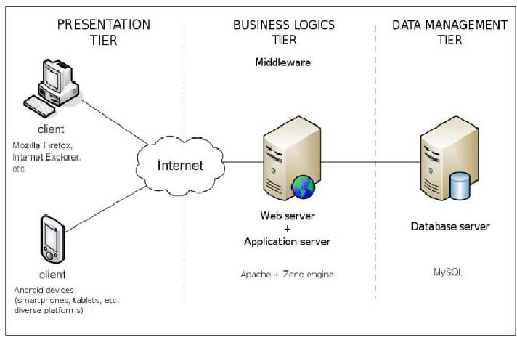

## 2.9 NLA

**Scenario:**

Blood bank Nepal is NGO organization that has asked to develop a web-based application, to keep record of various donor detail and campaign detail. It must enable any individual or staff of any hospital or blood bank can keep a online record of donors with blood types and also keep record of campaigns done by their organization with their location. The main aim of this system is creating a digital record of blood donors and make the record available online so that various blood banks/hospital can share each other’s record of donors and blood type, so that they can find proper blood for an immediate patient on time. They have asked to have the following functionality,

1. Registration with valid organization detail such as Username, User_id, number, locations and organization registration number.
2. Secure database and login-logout system
3. Add donor detail with blood type.
4. View, update and delete donor detail
5. Add Campaign detail with blood type.
6. View, update and delete campaign detail.

List of candidate noun and verbs:

|  |
| --- |
| Blood, bank, Nepal, Organization, blood, types, online, Donor, donors, proper,  Record, records, hospitals, login, add, view, delete, find, main, aim, details, registration, keep, location, ask, campaign, hospitals, details, web, donors, logout, number, username, user_id |

Final candidate class and methods are selected using the following rules:

* Repeated nouns and verbs are removed
* Synonyms are removed
* Irrelevant nouns and verbs are removed.
* Complex meaning noun and verb are removed along with those that could be in future development.

Following the above rules following final class and method are selected.

Final class:

|  |
| --- |
| Login  Registration  Donor  Campaign |

Final Method:

|  |
| --- |
| Add  Update  Delete  Login  Logout  Username  User_id |

2.9.1 Initial Class diagram:

Figure 1 initial class diagram

# Chapter 3: Design

Design is an important phase of development which determines how system should be built. It's the critical step in which logical and physical project preparation is conducted. It incorporates system functionality based on user requirements. Requirements in this stage are transformed into comprehensive and detailed system design specification.

## 3.1 Structural Modeling

The structural modeling shows my system's structural diagram by displaying the relationship from architecture map between classes, attributes, entity and process.

## 3.2 Final Class Diagram

The Class diagram are the class structure diagrams that is the part of unified UML language modeling that provides and defines an overview of the classes, relationship, attributes and methods between different objects and classes in a system.

**Justification for using class diagram:**

1. **Helps identify the class structure and how it interacts with each other before writing code that leads to more robust application development.**
2. **This helps to reduce maintenance time as the diagram gives an explanation of the layout of the specification.**
3. **Shows the type of classes and object that exists in the system and various kinds of static relationships.**

**Final class diagram:**

Figure 2 final class diagram

**Notations Used:**

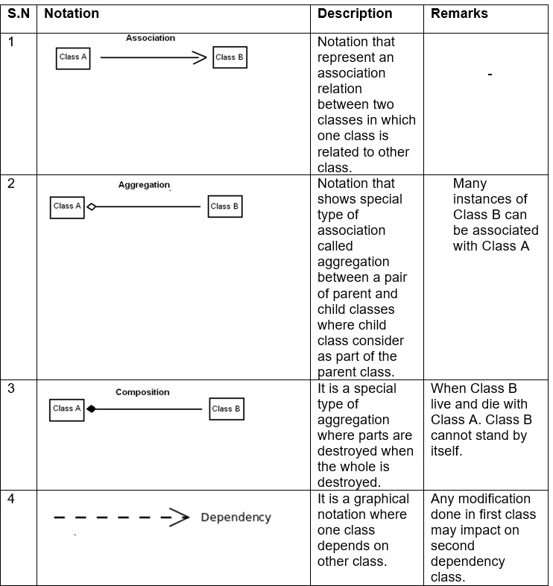

## 3.3 Data Flow Diagram (DFD)

DFD is a visual representation of how information flows through a system or process of business information. Furthermore, it is represented how information is supplied and received from the system, source a well as destination of this information, and where this information is stored. It simplifies system implementation process by visually representing process and system that would be difficult to understand if represented in large portions of text documents.

Justification for using DFD:

* + - * Enables definition of system boundaries.
      * Assists in enhancing users’ knowledge of the system.
      * A basic graphical tool that is easy to use and recognize.
      * Presents comprehensive system description and its elements.

Notations for DFD:

DFD Explanation for user

1. External "User" entity provides login credentials for the "Login System" process, which is then checked with the Registration Table from the data store. If credentials are shown as valid dashboard otherwise error message will be sent to the user.
2. User enters the dashboard after valid credentials are issued which possesses donor management and campaign management processes.
3. For Manage donor Process:
   * Adds new donor information and data is stores in blood donor table.
   * The donor table displays the donor information to the user.
   * Further, user can update donor information that is store in blood donor table.
   * Similarly, user can delete donor information which is in turn deleted from data blood donor table.
4. For Manage campaign Process:
   * Adds new campaign information and data is stores in campaign table.
   * The campaign table displays the campaign information to the user.
   * Further, user can update campaign information that is store in campaign table.
   * Similarly, user can delete campaign information which is in turn deleted from data campaign table.

# 3.4 Behavioral Modelling

The behavioral modeling is a UML depiction that represents a system's internal behavior. This focuses on the system's dynamic view and not the way it's applied. This represents the workflows by means of sequence of communication between objects to provide functionality and data changes.

## 3.4.1 Activity Diagram:

Activity diagram shows the system flow control and the steps involved from start to finish point showing the various decision paths that occur when performing a use case activity Here the dynamic system can be interpreted as both the concurrent and the sequential processing of an operation.

Figure 3activity daigram

In the above activity diagram, the user of various organization, first register their credential then the system authenticates their registration information. Then the user can login to the system using his/her username and password, then after login the system present them with dashboard which has three 6 parallel option to add, edit, view, delete: donors and campaigns. Then all the input added or removed to the dashboard is either add or removed from the storage depending on the user action. Then there is the logout button from where they can logout out of the system.

## 3.4.2 Sequence Diagram

Sequence diagrams in UML are diagrams of interactions that describe how operations are performed. In the sense of a collaboration they capture the interaction between objects. It captures how different system objects interact with each other in collaboration. These diagrams are time-centric and visually represent the order of the interaction by using the diagram's vertical axis to represent what messages are being sent.

Notation used:

Diagram:

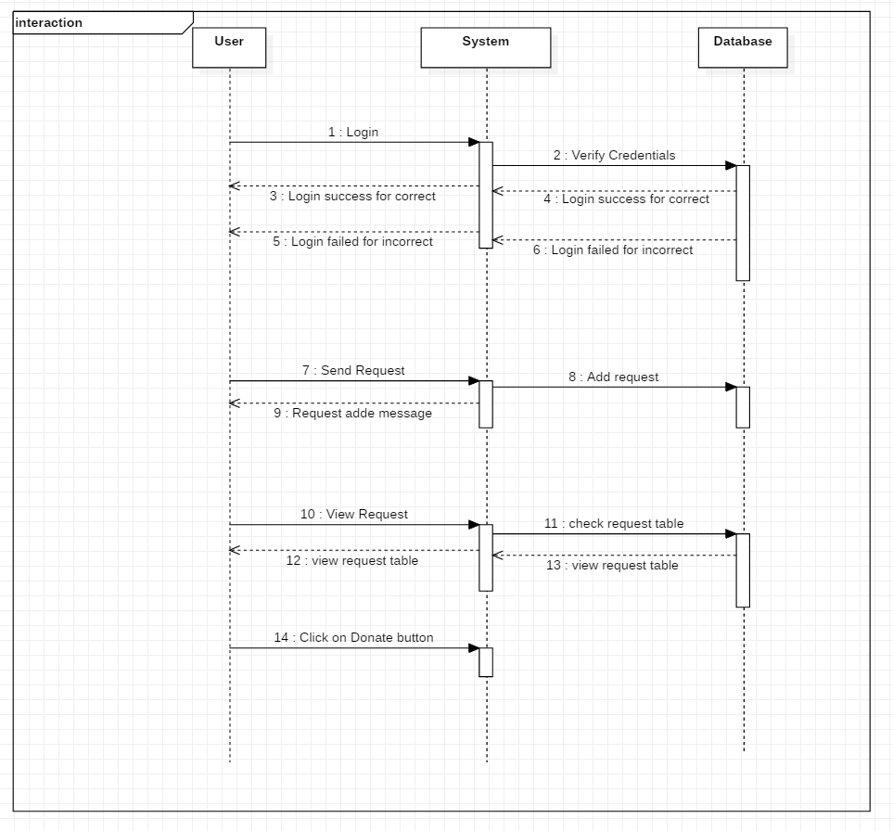

Figure 4 sequence daigram

From the example above, when a user logs in, they can only access their accounts if otherwise the credential given is right, they cannot. When the user sends request by filling out the form, the system adds a request to a database request table. Users send messages for viewing the requests, testing the system in the database, and responding as the database replied, and showing the table needed. When the user clicks the button on the table of requests the request status is updated.

# Chapter 4: Implementation

For the development of my system blood donor registration system I have chosen core PHP as my programing language with html and JavaScript, also OOP Pattern of code architecture was use for the fast programing of the system. These frameworks provide built in fictionality and secure authentication process.

## 4.1 UI-Modelling

User Interface Modelling is a visual user interface designing used by application developer to develop front end design for various software. For my project UI design is important because it helps to make design more user-friendly and shows how my project design will look. I have used an interface designing tool called Balsamiq to design the UI of my project.

## 4.1.1 Prototype:

UI model of login page:

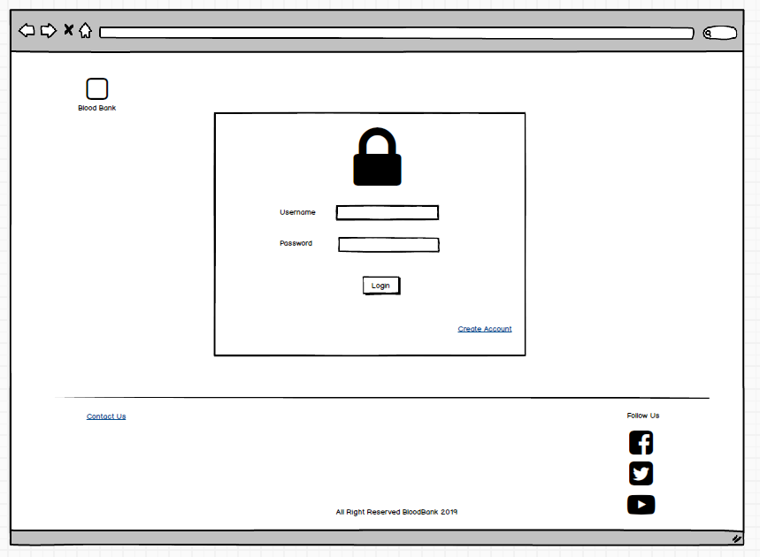

Figure 5 for login page

UI model of registration page:

Figure 6 registration model

UI modeling of dashboard:

Figure 7 dashboard model

# Chapter 5 Testing

## 5.1 Blackbox Testing:

Blackbox is the testing methodology where the software's functionality is evaluated without much understanding of the tester implementation or internal structure.

## 5.1.1 Benefits of black box testing:

1. The developer doesn’t need not have technical background to conduct this testing.
2. Analysis is carried out from a tester perspective.
3. Cases may be designed immediately after completion of functional specification test cases.
4. A proof of the functional requirement

|  |  |  |  |  |  |
| --- | --- | --- | --- | --- | --- |
| **Test Name:** | | Donor CRUD functionality test | | | |
| **Test By:** | | Sohail maharjan | **Test Location:** | Ravibhawan | |
| **Approved By:** | | Sudeep Bajimaya | **Test Time:** | 15:35, Monday, 2020-01-25 | |
| **Case ID** | **Description** | **Data** | **Expected Results** | **Actual Results** | **Remark** |
| DCF03 | Add donor information | Name: sohail  Gender: male  Date: 02/31/0190  Weight:44  Contact:9812376  Blood type: AB | Added successfully. | The field is incorrect, invalid date | Failed |
| DCF04 | Add donor information | Name: sohail  Gender: male  Date: 01/31/0190  Weight:44  Contact:9812376  Blood type: AB | Added successfully. | Added successfully | Success |
| DCF05 | View donor information | Click on view donor | Donor list is displayed | Donor list is displayed | Success |
| DCF06 | Edit donor | Click on view edit donor | Edit donor is opened | Edit donor is opened | Success |
| DCF07 | Edit donor | Name: sam  Gender: female  Date: 02/31/0190  Weight:44  Contact:9812376  Blood type: AB | Update successful | Update successful | success |
| DCF08 | Remove donor | Click on remove donor | Donor list remove successfully | Donor list remove successfully | success |

|  |  |  |  |  |  |
| --- | --- | --- | --- | --- | --- |
| **Test Name:** | | Blood CRUD functionality test | | | |
| **Test By:** | | Sohail maharjan | **Test Location:** | Ravibhawan | |
| **Approved By:** | | Sudeep Bajimaya | **Test Time:** | 15:35, Monday, 2020-01-25 | |
| **Case ID** | **Description** | **Data** | **Expected Results** | **Actual Results** | **Remark** |
| BCF03 | Create Campaign information | Campaign Name: Blood notaion nepal  Organization name: Who  Date: 02/31/2020  Location: Ravhibhawan  Description: test | Campaign created. | The field is incorrect, invalid date | Failed |
| BCF04 | Create Campaign information | Campaign Name: Blood notaion nepal  Organization name :Who  Date: 06/08/2020  Location: Ravhibhawan  Description: test | Campaign created. | Campaign created. | Success |
| BCF05 | View Campaign information | Click on view Campaign | Campaign list is displayed | Campaign list is displayed | Success |
| BCF06 | Edit Campaign | Click on view edit Campaign | Edit Campaign is opened | Edit Campaign is opened | Success |
| BCF07 | Edit Campaign | Campaign Name: Nepal Who  Organization name: Who  Date: 06/08/2020  Location: tesr  Description: test | Update successful | Update successful | success |
| BCF08 | Remove Campaign | Click on remove Campaign | Campaign list remove successfully | Campaign list remove successfully | success |

Results:

|  |  |  |  |  |  |
| --- | --- | --- | --- | --- | --- |
| DCF03 | Add donor information | Name: sohail  Gender: male  Date: 02/31/0190  Weight:44  Contact:9812376  Blood type: AB | Added successfully. | The field is incorrect, invalid date | Failed |

Screenshot:

Figure 8 DCF03

|  |  |  |  |  |  |
| --- | --- | --- | --- | --- | --- |
| DCF04 | Add donor information | Name: sohail  Gender: male  Date: 01/31/0190  Weight:44  Contact:9812376  Blood type: AB | Added successfully. | Added successfully | Success |

Screenshot of the test:

Figure 9 DCF04

|  |  |  |  |  |  |
| --- | --- | --- | --- | --- | --- |
| DCF05 | View donor information | Click on view donor | Donor list is displayed | Donor list is displayed | Success |

Screenshot of the test:

Figure 10 DCF05

|  |  |  |  |  |  |
| --- | --- | --- | --- | --- | --- |
| DCF06 | Edit donor | Click on edit. | Edit donor is opened | Edit donor is opened | Success |

Figure 11 DCF06

|  |  |  |  |  |  |
| --- | --- | --- | --- | --- | --- |
| DCF07 | Edit donor | Name: sam  Gender: female  Date: 02/31/0190  Weight:44  Contact:9812376  Blood type: AB | Update successful | Update successful | success |

Figure 12 DCF07

|  |  |  |  |  |  |
| --- | --- | --- | --- | --- | --- |
| DCF08 | Remove donor | Click on remove donor | Donor list remove successfully | Donor list remove successfully | success |

Figure 13 DCF08

Figure 14 DCF08

|  |  |  |  |  |  |
| --- | --- | --- | --- | --- | --- |
| BCF03 | Create Campaign information | Campaign Name: Blood notaion nepal  Organization name: WholDate: 02/31/2020  Location: Ravhibhawan  Description: test | Campaign created. | The field is incorrect, invalid date | Failed |

Figure 15 BCF03

|  |  |  |  |  |  |
| --- | --- | --- | --- | --- | --- |
| BCF04 | Create Campaign information | Campaign Name: Blood notaion nepal  Organization name :Who  Date: 06/08/2020  Location: Ravhibhawan  Description: test | Campaign created. | Campaign created. | Success |

Figure 16 BCF04

|  |  |  |  |  |  |
| --- | --- | --- | --- | --- | --- |
| BCF05 | View Campaign information | Click on view Campaign | Campaign list is displayed | Campaign list is displayed | Success |

Figure 17 BCF05

|  |  |  |  |  |  |
| --- | --- | --- | --- | --- | --- |
| BCF06 | Edit Campaign | Click on view edit Campaign | Edit Campaign is opened | Edit Campaign is opened | Success |

Figure 18 BCF06

|  |  |  |  |  |  |
| --- | --- | --- | --- | --- | --- |
| BCF07 | Edit Campaign | Campaign Name: Nepal Who  Organization name: Who  Date: 06/08/2020  Location: tesr  Description: test | Update successful | Update successful | Success |

Figure 19 BCF07A screenshot of a cell phone

Description automatically generated

Figure 20 BCF08

|  |  |  |  |  |  |
| --- | --- | --- | --- | --- | --- |
| BCF08 | Remove Campaign | Click on remove Campaign | Campaign list remove successfully | Campaign list remove successfully | success |

Figure 21 BCF08

# 

# 6.User manual:

It is a practical interaction report which provides the device user with assistance on how to navigate and use the system. It includes both images and text guide associated with system. It is common to find screenshots of the computer applications in User manual.

User dashboard:

Step1: Click on create account to register and fill it with valid credentials.

Step 2: Login with the registration credential

Step 3: Click on donor to add, edit, view and delete donor:

Step 4: Click on campaign to add, edit, view and delete.

Step 6: Click of view donor to view donor info:

Step 7: Click on edit donor to update the Donor info:

Step 8: Click of Remove donor to delete the donor info:

Step 9: Click on campaign create campaign to add campaign info:

Step 12: Click on View campaign to View Campaign info:

Step 13: Click on delete to delete campaign information:

# Chapter 7

## 7.1 Problem faced:

The issues faced during the development of the project are stated bellow:

* Due to improper database connection the system was not functioning at first but through some guidance I managed resolve the issue.
* Creating the proper login system with organization authentication was quite tricky.
* The webpage has very heavy to load, so I had to make it light weight.
* The login page was failing to login and index page did not load some time but with some assistance I solved the issue.

## 7.2 Limitations:

Scope of this project is limited to only valid organization staff, any user not part of a blood collecting organization such as blank banks or hospital, cannot access the system. Because this is a web base application, it requires internet to operate at any level so, without it; it's basically useless. To use this application client needs to have some degree of formal educational background. Illiterate people might have difficulties operating in this system. This project is limited to serve in a limited geographical area like a town or a city.

## 7.3 Risk management:

Risk management is generally refers to identification, prioritization and evaluation of risks followed by cost-effective and coordinated resource utilization to monitor, control and minimize the effect or probability of unfortunate events or to maximize the opportunities. The programming related, environmental, and process risks are types of hazards that each software engineering project faces during its development. The process of defining these hazards, lowering their likelihood or likelihood of occurrence, and reducing the effect of these threats if a project succeeds.

After a risk is detected an effective plan is deployed within the system to cancel or minimize the risk factor.

Likelihood table:

|  |  |
| --- | --- |
| Likelihood | Value |
| Low | 1 |
| Medium | 2 |
| High | 3 |

Risk consequences table:

|  |  |
| --- | --- |
| Consequences | Values |
| Very low | 1 |
| Low | 2 |
| Medium | 3 |
| High | 4 |
| Extreme | 5 |

|  |  |  |  |  |
| --- | --- | --- | --- | --- |
| SN | Risk | Likelihood | Consequence | Actions |
| 1 | Time shortage | 2 | 5 | Proper project management should be done with proper time allocation |
| 2 | Equipment failure | 1 | 5 | All the data should be backed up in more than one device |
| 3 | Server failure | 1 | 4 | Data should be backed up on a daily basis |
| 4 | Viruses | 3 | 3 | Antivirus software should be used |
| 5 | Over budget0 | 1 | 3 | Budget should be properly allocated and spend on the task rather than personal gains |

Table: Risk analysis

## 7.5 Configuration management

Mechanism to cope with a project plan's various technical problems. Effective software configuration management can be improved in a software organization productivity through enhanced coordination between a team's programmers. Configuration management is the collective project of process activities, methods and tools where items are managed by practitioners throughout the life cycle of the project.

The activities of configuration management are given below;

**Change management:**

Systematic method that addresses change in the process or goals of the organization. These management's main aim is to implement policies to control change, effect change, and help individuals accommodate change.

**Release management**

Method that is responsible for planning and controlling construction as well as testing release and release deployment. Its goal is to safeguard the integrity of the living setting and release precise components.

**Version control**

It could be a framework that keeps records of a collection of records that have been changed over a period so that you just can keep in mind forms afterward. The most reason for actualizing usually to promptly recuperate from blunders made, survey past alterations, participation with designers, and reinforcement of code. We have proposed to utilize GitHub as version control for this project.

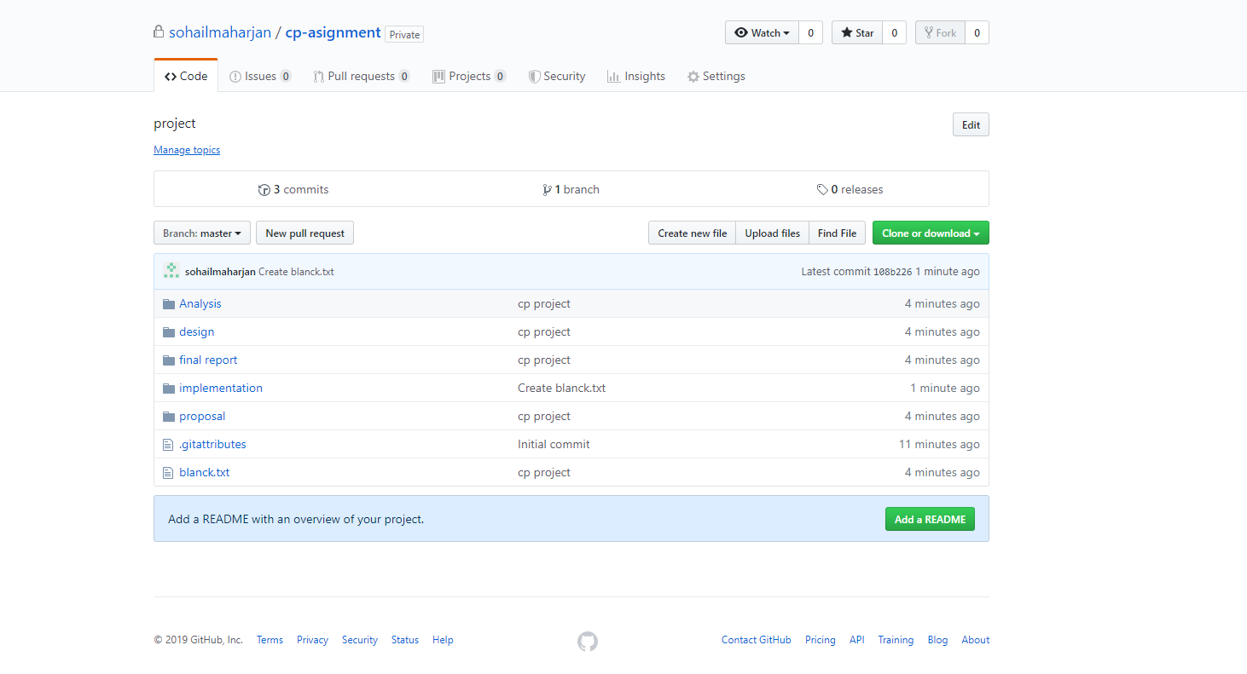

Link: https://github.com/sohail-maharjan/cp_project.git

## 7.6 Future Work

In the future I would like to add a lot of features such as:

1. Public donor registration and login system.
2. Separate dashboard for public use.
3. Donor statistic report system.
4. Location tracking of donor nearby.

# Conclusion:

To complete this task, I have performed number of analysis, designing, implementation, risk management and various other researchers. Hence looking at this project I see great potentially in this system, I believe it will be of great use for hospitals and blood banks of Nepal. I designed this system with a noble cause of helping people and saving life, and I have full confidence that it will fulfill that cause.

# Appendix:

## Codes:

Code of database connection:

### Codes for View donor:

### Code for deleting donor:

### View campaign:

